Pentagonal Trapezohedron

Definition
# Source: AI Source: Provided by: [Data Path: Persons Table -> ID Column: 1, Name_En Column: Motasem Essam] -> From: [ChatGPT] on [7/25/2026]
A Pentagonal Trapezohedron is a convex polyhedron consisting of 10 congruent kite-shaped faces, arranged symmetrically around a central fivefold rotational axis.
It has two opposite axial vertices (one at each end of the axis) and five vertices forming a middle ring.
It is also called a Pentagonal Deltohedron.

Simple Definition
# Source: AI Source: Provided by: [Data Path: Persons Table -> ID Column: 1, Name_En Column: Motasem Essam] -> From: [ChatGPT] on [7/25/2026]
A pentagonal trapezohedron is a three-dimensional solid made of ten identical kite-shaped faces arranged around a central axis, with five vertices forming a ring around its middle.
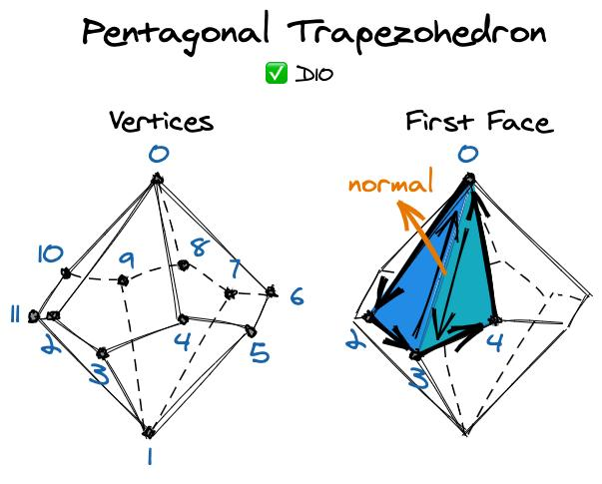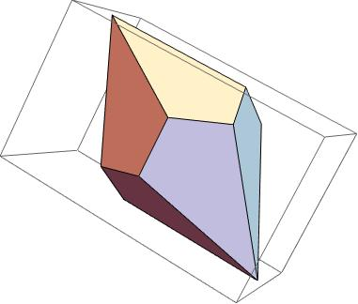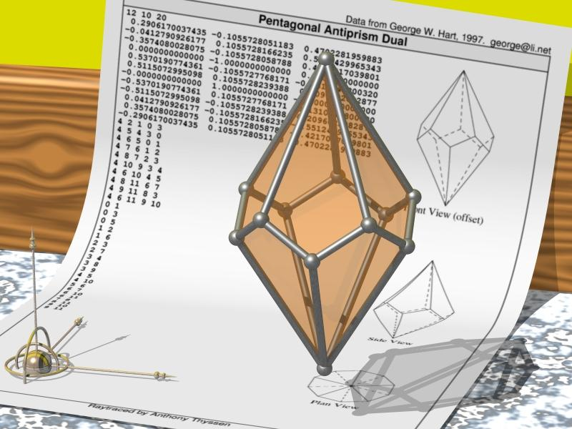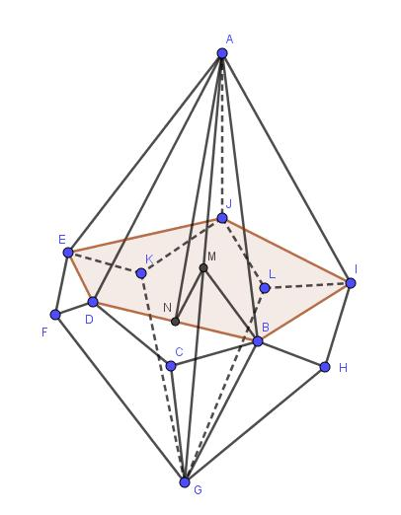

Geometric Structure
# Source: AI Source: Provided by: [Data Path: Persons Table -> ID Column: 1, Name_En Column: Motasem Essam] -> From: [ChatGPT] on [7/25/2026]
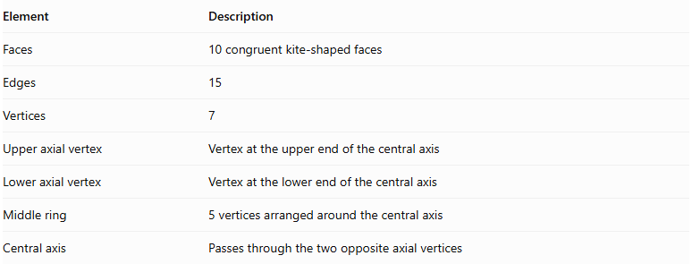
Element | Description
Faces | 10 congruent kite-shaped faces
Edges | 15
Vertices | 7
Upper axial vertex | Vertex at the upper end of the central axis
Lower axial vertex | Vertex at the lower end of the central axis
Middle ring | 5 vertices arranged around the central axis
Central axis | Passes through the two opposite axial vertices

Face Structure
# Source: AI Source: Provided by: [Data Path: Persons Table -> ID Column: 1, Name_En Column: Motasem Essam] -> From: [ChatGPT] on [7/25/2026]
Each face is a kite-shaped quadrilateral with:
- Two pairs of adjacent equal-length sides.
- One pair of equal opposite angles.
- Perpendicular diagonals.
- One diagonal that bisects the other.
The ten faces are congruent and form a closed convex surface.

Edge Structure
# Source: AI Source: Provided by: [Data Path: Persons Table -> ID Column: 1, Name_En Column: Motasem Essam] -> From: [ChatGPT] on [7/25/2026]
The 15 edges can be classified into three groups:
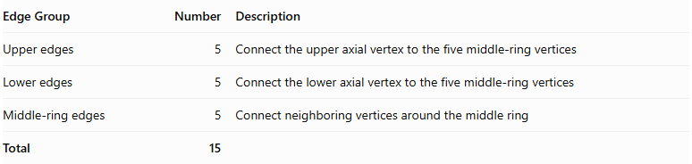
Edge Group | Number | Description
Upper edges | 5 | Connect the upper axial vertex to the five middle-ring vertices
Lower edges | 5 | Connect the lower axial vertex to the five middle-ring vertices
Middle-ring edges | 5 | Connect neighboring vertices around the middle ring
Total | 15

Vertex Structure
# Source: AI Source: Provided by: [Data Path: Persons Table -> ID Column: 1, Name_En Column: Motasem Essam] -> From: [ChatGPT] on [7/25/2026]
The pentagonal trapezohedron has seven vertices:
- 1 upper axial vertex.
- 1 lower axial vertex.
- 5 middle-ring vertices.
$$V=2+5=7$$
In its standard symmetric form:
- Five faces meet at each axial vertex.
- Four faces meet at each middle-ring vertex.

Mathematical Properties
# Source: AI Source: Provided by: [Data Path: Persons Table -> ID Column: 1, Name_En Column: Motasem Essam] -> From: [ChatGPT] on [7/25/2026]
For a pentagonal trapezohedron, $n=5$.

A. Number of Faces
# Source: AI Source: Provided by: [Data Path: Persons Table -> ID Column: 1, Name_En Column: Motasem Essam] -> From: [ChatGPT] on [7/25/2026]
$$F=2n=2(5)=10$$

B. Number of Edges
# Source: AI Source: Provided by: [Data Path: Persons Table -> ID Column: 1, Name_En Column: Motasem Essam] -> From: [ChatGPT] on [7/25/2026]
$$E=3n=3(5)=15$$

C. Number of Vertices
# Source: AI Source: Provided by: [Data Path: Persons Table -> ID Column: 1, Name_En Column: Motasem Essam] -> From: [ChatGPT] on [7/25/2026]
$$V=n+2=5+2=7$$

D. Euler's Formula
# Source: AI Source: Provided by: [Data Path: Persons Table -> ID Column: 1, Name_En Column: Motasem Essam] -> From: [ChatGPT] on [7/25/2026]
$$V-E+F=2$$
$$7-15+10=2$$
<badge color="success">Verified</badge> Euler's formula is satisfied.

Symmetry
# Source: AI Source: Provided by: [Data Path: Persons Table -> ID Column: 1, Name_En Column: Motasem Essam] -> From: [ChatGPT] on [7/25/2026]
A standard symmetric pentagonal trapezohedron has:
- A fivefold rotational symmetry axis.
- Fivefold rotational symmetry around its central axis.
- Five vertical reflection planes containing the central axis.
- Central inversion symmetry when its upper and lower portions are arranged symmetrically.

Constructing Pentagonal Trapezohedron in Solid Geometry

Geometric Instruments Used
# Source: AI Source: Provided by: [Data Path: Persons Table -> ID Column: 1, Name_En Column: Motasem Essam] -> From: [ChatGPT] on [7/25/2026]
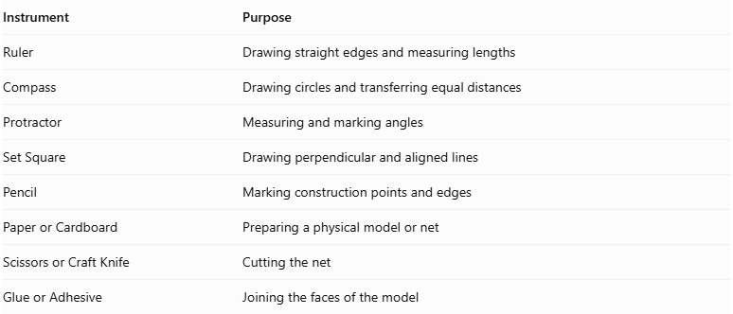
Instrument | Purpose
Ruler | Drawing straight edges and measuring lengths
Compass | Drawing circles and transferring equal distances
Protractor | Measuring and marking angles
Set Square | Drawing perpendicular and aligned lines
Pencil | Marking construction points and edges
Paper or Cardboard | Preparing a physical model or net
Scissors or Craft Knife | Cutting the net
Glue or Adhesive | Joining the faces of the model

Instrument-Based Construction Procedures
# Source: AI Source: Provided by: [Data Path: Persons Table -> ID Column: 1, Name_En Column: Motasem Essam] -> From: [ChatGPT] on [7/25/2026]
The pentagonal trapezohedron can be constructed using geometric instruments through a symmetry-based drawing process.

Preparing the Central Axis
# Source: AI Source: Provided by: [Data Path: Persons Table -> ID Column: 1, Name_En Column: Motasem Essam] -> From: [ChatGPT] on [7/25/2026]
- Draw a vertical reference line representing the central axis.
- Mark the intended upper and lower axial vertices.
- Establish the central region where the two staggered vertex rings will be positioned.

Constructing the Two Vertex Rings
# Source: AI Source: Provided by: [Data Path: Persons Table -> ID Column: 1, Name_En Column: Motasem Essam] -> From: [ChatGPT] on [7/25/2026]
- Use a compass to draw the reference circles for the upper and lower rings.
- Divide each circle into five equally spaced positions.
- Use a protractor to mark the five positions at equal angular intervals of ${72}^{∘}$.
- Offset the second ring relative to the first to create the staggered arrangement.
- Mark the five vertices on each ring.

Marking the Axial Vertices
# Source: AI Source: Provided by: [Data Path: Persons Table -> ID Column: 1, Name_En Column: Motasem Essam] -> From: [ChatGPT] on [7/25/2026]
- Mark the upper axial vertex above the upper ring.
- Mark the lower axial vertex below the lower ring.
- Align both vertices with the central axis.

Constructing the Kite-Shaped Faces
# Source: AI Source: Provided by: [Data Path: Persons Table -> ID Column: 1, Name_En Column: Motasem Essam] -> From: [ChatGPT] on [7/25/2026]
- Connect the upper axial vertex to the appropriate vertices of the upper and lower rings.
- Connect the lower axial vertex to the corresponding vertices of the two rings.
- Join neighboring vertices from the two rings according to the trapezohedron's face arrangement.
- Form ten kite-shaped quadrilateral faces.
- Check that all shared edges have matching lengths and that the faces close into a convex solid.

Completing the Three-Dimensional Drawing
# Source: AI Source: Provided by: [Data Path: Persons Table -> ID Column: 1, Name_En Column: Motasem Essam] -> From: [ChatGPT] on [7/25/2026]
- Draw the visible edges using continuous lines.
- Represent hidden edges using dashed lines when necessary.
- Check that all ten faces are connected correctly.
- Verify that the drawing contains 12 vertices and 20 edges.
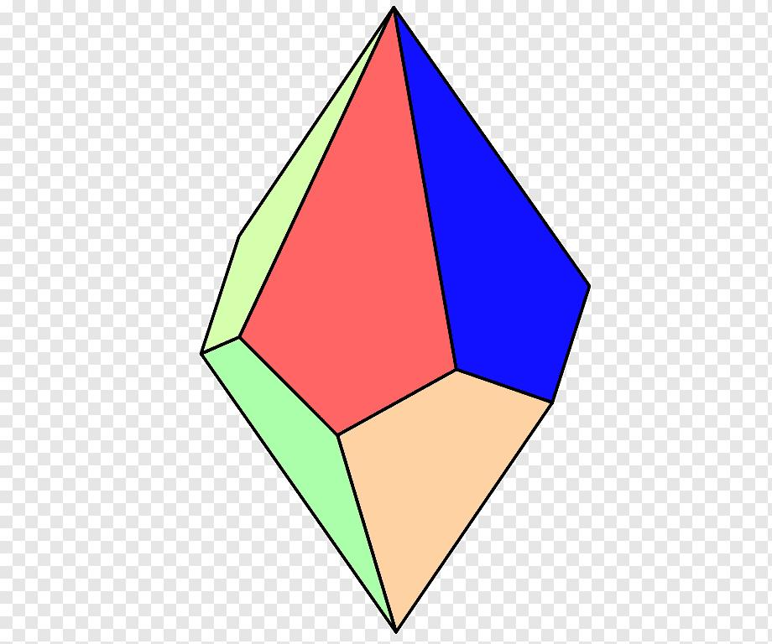

Constructing a Physical Model
# Source: AI Source: Provided by: [Data Path: Persons Table -> ID Column: 1, Name_En Column: Motasem Essam] -> From: [ChatGPT] on [7/25/2026]
- Draw a valid net containing ten correctly connected kite-shaped faces.
- Add tabs along selected outer edges.
- Cut out the net carefully.
- Fold along the shared face boundaries.
- Join corresponding edges using adhesive.
- Check that the assembled model forms a closed pentagonal trapezohedron.
Construction note: This is an instrument-based geometric construction using rulers, compasses, protractors, and geometric relationships. It does not use coordinate-based construction.

Relationship to Other Trapezohedra
# Source: AI Source: Provided by: [Data Path: Persons Table -> ID Column: 1, Name_En Column: Motasem Essam] -> From: [ChatGPT] on [7/25/2026]
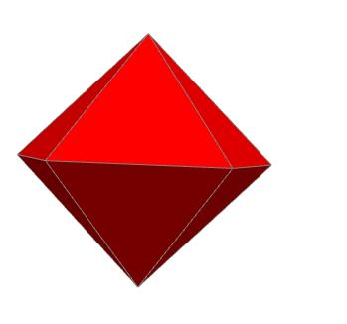
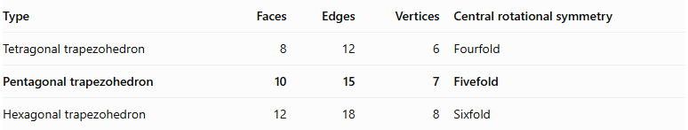
Type | Faces | Edges | Vertices | Central rotational symmetry
Tetragonal trapezohedron | 8 | 12 | 6 | Fourfold
Pentagonal trapezohedron | 10 | 15 | 7 | Fivefold
Hexagonal trapezohedron | 12 | 18 | 8 | Sixfold

Key Points
# Source: AI Source: Provided by: [Data Path: Persons Table -> ID Column: 1, Name_En Column: Motasem Essam] -> From: [ChatGPT] on [7/25/2026]
- A pentagonal trapezohedron has 10 congruent kite-shaped faces.
- It has 15 edges and 7 vertices.
- Five vertices form its middle ring.
- Two vertices lie at opposite ends of its central axis.
- Its standard symmetric form has a fivefold rotational axis.
- It satisfies Euler's polyhedron formula.

Conclusion
# Source: AI Source: Provided by: [Data Path: Persons Table -> ID Column: 1, Name_En Column: Motasem Essam] -> From: [ChatGPT] on [7/25/2026]
The Pentagonal Trapezohedron is a fivefold form of a trapezohedron, characterized by ten congruent kite-shaped faces arranged around a central axis. It has seven vertices, fifteen edges, and a fivefold rotational symmetry axis.
Classification note: Like the tetragonal trapezohedron, it is topologically equivalent to a bipyramid over a pentagon, but its faces are kite-shaped quadrilaterals rather than triangles.

